Composition Journal
Should Kids Get Paid to do Chores?

Sum up each argument’s central claim was.
What made the strongest argument, in your opinion?

Where do you fit in this argument? Please write a response to the debate topic on getting paid to do chores. Remember, the best argument is supported with evidence and rebuttals to counterarguments.
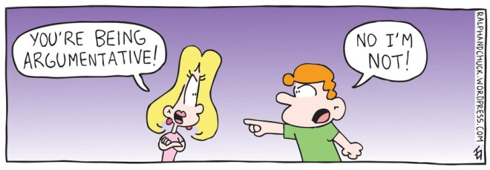
Be ready to “debate” your argument.

