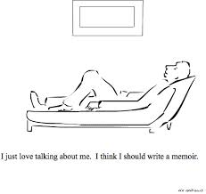
MEMOIR UNIT
Teen Memoir activity
Choose any 2 memoirs online from the following links:
http://www.csun.edu/~hflrc001/fall09/sample-memoirs.html
http://www.teenink.com/nonfiction/memoir/
http://teacher.scholastic.com/writeit/readwork.asp?Genre=Memoir
Memoir 1:
- What moment or event is being described in the memoir?

- What were the author’s feelings BEFORE this moment or event?

- What are the author’s feelings AFTER this moment or event?

- Explain what the author’s new realization or understanding is from this moment or event.

Memoir 2:
- What moment or event is being described in the memoir?

- What were the author’s feelings BEFORE this moment or event?

- What are the author’s feelings AFTER this moment or event?

- Explain what the author’s new realization or understanding is from this moment or event.
Comparing Texts
- What do these two memoirs have in common?

- What makes them memoirs?

- Who is telling the story in both?

- How much time passes in each memoir?

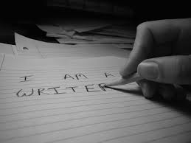
- Why would someone write about their own life?

