A reflection paper is more academic than a journal entry but less formal than a traditional research paper. A reflection paper is mostly about you. Writing a reflection allows you the chance to reinforce what you learned from the article and react to how you personally feel about it. There is no need to bring up counter-arguments or counterpoints in this sort of paper.

Step 1
Provide a brief summary. Write a narrative of your experience with the article. Detail factual information, as well as your feelings and impressions. Kind of a “They Say/I Say”

Step 2
Compare your experience with your prior knowledge. How does the information relate to you? What did it make you think of? What are future implications of this topic?

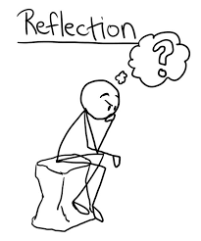
Step 3
Edit your paper.

