Theme: Understanding the literary elements in Poetry and how they are used within poems.
Literary terms:
1. Alliteration:_________________________________________________________

2. Simile:____________________________________________________________

3. Metaphor:__________________________________________________________

4. Personification:______________________________________________________

5. Onomatopoeia:_______________________________________________________

6. Rhyme:____________________________________________________________

7. Hyperbole _________________________________________________________

8. Tone _____________________________________________________________

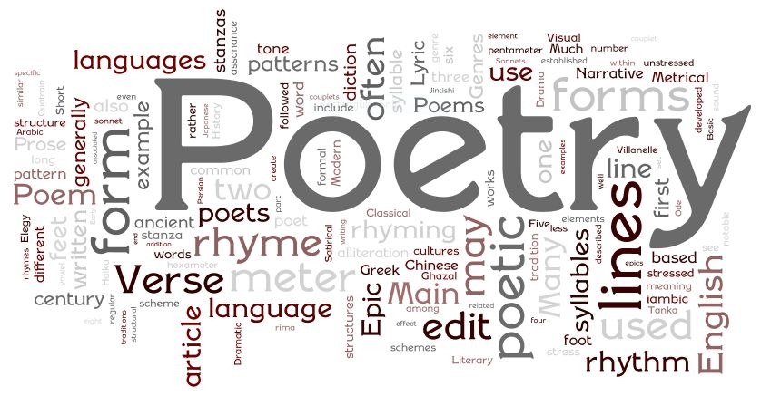
Robert Frost Questions
9. When was Robert Frost born and where?
____________________________________
10. How many Pulitzer awards did Robert Frost win?
____________________________________

Poems:
11. Read “Acquainted with the Night” and write an example of alliteration.
___________________________________________________________________

12. Read “Predictable” and write two examples of similes.
_______________________________________________________________
_______________________________________________________________

13. Read “Metaphor for a Family” and write two examples of a metaphor used to describe her family.
_______________________________________________________________
_______________________________________________________________

14. Read “Road Not Taken” and write an example of personification.
___________________________________________________________________

15. Read “Camping” and write all the examples of Onomatopoeia.
___________________________________________________________________

16. Read “Stopping by Woods on a Snowy Evening” and write the words that Rhyme.
___________________________________________________________________

17. Read one of the four poems and write which poem you read and one example of a hyperbole.
___________________________________________________________________
___________________________________________________________________

